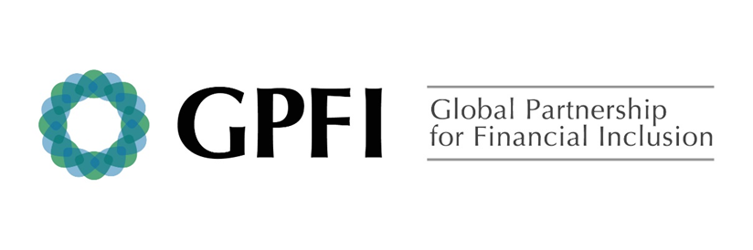

G20 National Remittance Plan 2019
Spain

Background
Migrant Population, Remittance outflow and main corridors
Migrants accounted 10% of people living in Spain in 2018, the biggest shares being from Morocco and Romania (15% each), according to the National Statistics Institute. From the information declared by the remittance sector under supervision of the Bank of Spain, the flow outside Spain was 7,154 million euros in 2018, and the main corridors are: Latin America (Bolivia, Brazil, Colombia, Dominican Republic, Ecuador, Honduras and Peru), Bulgaria and Romania, in Europe, Morocco and Nigeria, in Africa; the Philippines and China, in Asia.
Remittance costs reduced in 2018
The average cost of a 200-dollar remittance transfer from Spain was 5.6% in 2018, (5.7% in 2017). By destination, the lowest cost of such transfer from Spain is to the Philippines (4.6%), followed by Peru (4.8%) and Dominican Republic (4.9%). On the other side, China (13.2%) and Nigeria (7.3%) are the most expensive remittance corridors from Spain .
2019 Country plan for reducing remittance transfer costs
Spanish authorities are focused on:
Increasing competitiveness, facilitating the entrance of Fintech Service Providers.
- The Payment Services Directive 2015/2366 (PSD2) provides room for new activities and actors related to payment services, such as those offered by financial technology companies (FinTechs). The Directive has been transposed to the Spanish regulation.

- Besides EU regulation, common to all Member States, at national level a draft law for the Digital Transformation of the Spanish Financial Sector was approved by the Spanish Government in February 2019. This draft law seeks to support innovation, facilitate the digital transformation in the financial sector and benefit the economy as a whole, safeguarding four pillars: consumer protection, financial stability, market efficiency and the fight against money laundering and the financing of terrorism (AML/FT). In short, the aim is to balance the desire to support the digital transformation of the economy with the need to control the risks involved, adding new tools for supervisors and regulators. The draft establishes the application of the principle of proportionality between activities and risks in the financial field.

Building a healthy financial system infrastructure, supporting innovation and the use of emerging technologies as well as improving the regulatory environment.
- Remote on-boarding is allowed in our regulation (Article 21.1 d, from the Royal Decree 304/2014 of 5 May, implementing Law 10/2010 of 28 April, on the prevention of money laundering and terrorist financing), giving the possibility of using alternative methods of consumer´s identification, such as videoconference (subject to previous authorization from the Spanish FIU-SEPBLAC).

- The draft law for the Digital Transformation of the Spanish Financial Sector (approved by the Spanish Government in February 2019) includes a Regulatory Sandbox to promote FinTech projects. The future Regulatory Sandbox foresees the creation of a flexible and controlled (but not “unregulated”) space to test different innovative projects.

- In March 2018 (and anticipating the incorporation of Spain to the European Blockchain Partnership -EBP in April 2018), the Treasury of Spain signed a cooperation MoU with Alastria, which is the world’s largest (more than 400 companies and institutions) non-profit multi-sector consortium promoting blockchain/distributed ledger technologies. Alastria’s aim is the establishment of a legally binding blockchain semi-public infrastructure fully aligned with European regulations, like GDPR. The European Commission has identified Alastria as a role model for interaction of the private sector with the future EBP’s infrastructure, and this MoU allows the Treasury of Spain closely watch the evolution of Alastria, in order to detect technological bias but also to learn how regulation could contribute to the adoption of blockchain/distributed ledger technologies to increase the resilience and efficiency of the economy

Enhancing Transparency and Consumer Protection
International technical assistance. Spain is very active in sharing knowledge and good practices with other countries through different channels and actors.
- Spain co-chairs the Financial Action Task Force (FATF) which actively promotes the development of standards and fosters regulatory cooperation between jurisdictions. FATF recently launched a new platform to share initiatives and developments or the benefit of governments and the private sector more broadly: FATF FinTech and RegTech Initiative.

- The topic of remittances and diaspora investments is included in Spain's V Master Plan for Cooperation (2018/2021) and the Spanish Agency for International Development Cooperation (AECID) will be implementing an initiative on financial inclusion under the European Investment Plan (EIP), which includes special attention to interventions on banking of remittances.

Private-public partnership at national level. Spanish authorities conduct outreach initiatives with different stakeholders such as workshops with compliance officers to share TF risk indicators as well as training sessions and consumer literacy projects involving the private sector

Facilitating end users’ access to transaction accounts offered by banks as well as non-banks
- Directive 2014/92/EU on the comparability of fees related to payment accounts, payment account switching and access to payment accounts with basic features it is transposed (see Royal Decree Law 19/2017). Two main features:
- Physical attendance at the premises of the credit institutions should not be required.
- Basic payment accounts are configured as a standardized financial product, which are required to be offered by all credit institutions with no exceptions other than a series of limited assumptions that allow their denial. In addition to this, the regulation of payment services applies to them (Order EHA / 1608/2010, of June 14, on transparency of the conditions and information requirements applicable to the payment services and Order EHA / 2899/2011, of October 28, on transparency and protection of the client of banking services).

- Spain actively contributes to the EU Commission expert group on electronic identification and remote Know-Your-Customer processes (E03571). Government and private sector experts provide their own experience on electronic identification and remote Know-Your-Customer processes based on eIDAS for the purposes of digital on-boarding.

