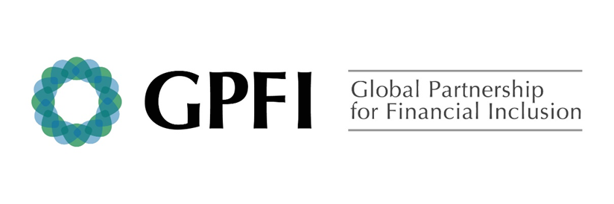

G20 National Remittance Plan 2019
Switzerland

Background
Switzerland is currently working on a number of legislative changes and guidelines with a view to provide a more tailored and optimized regulatory environment for the Swiss FinTech industry and the Blockchain tehncology. In this context, Switzerland is seeking innovative solutions that support the development of the FinTech industry, and by extensionalso digital-based solutions for payments / remittances. The Swiss financial ecosystem is currently home of many 372 Fintech, of which 1/3 are DLT/Blockchain start-ups.

In Switzerland, access to banking services – including retail payment systems – is not generally perceived as an issue. The same holds generally for access to remittances services. Also, the Swiss financial sector is part of the Single Euro Payments Area (SEPA) framework, which facilitates cross-border payments (incl. remittances) in EUR towards European countries. In addition, a number of new mobile money and other technology-enabled solutions are currently emerging in the Swiss financial sector. This includes solutions focusing on payments that are also leveraged for remittances transfers.

Call to action on remittances
Switzerland is commited to improving the country's position as an attractive location for digital innovations, while maintaining the integrity of the financial centre and ensuring technology-neutral regulation. Due to the rapidly progressing digitization in the financial sector, the Swiss authorities will continue to follow these developments closely in the future.

Switzerland advocates a comprehensive approach to migrants’ remittances, which can offer inroads for promoting financial inclusion in recipient countries, while ensuring full compliance with applicable AML/CFT regulation. Favorable framework conditions need to be fostered for the efficient operation of remittances services providers and for innovation to happen in this area. Switzerland also places great emphasis on the diagnostic side, supporting surveys in priority countries to better measure and profile levels of access to and use of financial services, in order to optimize the development impact of remittances in the country of destination.

Lastly, Switzerland is actively involved in the DLT technology. Due to the rapidly progressing digitization in the financial sector, the Swiss authorities will follow these developments closely in the future. Swiltzerlands want to foster the potential of the blockchain technology, while, at the same time, to guarantee the integrity and the good reputation of Switzerland as a business location.

2019 Country plan for reducing remittance transfer costs
- Increase remittance market competitiveness, including through improvements to the regulatory environment
Switzerland will continue overhauling its financial market regulation on the federal level. After entry into force of the Financial Market Infrastructure Act in January 2016, Swiss Parliament is currently working on two further projects, incl. two core pieces of the Swiss financial market architecture, the Financial Services Act (FinSA) and the Financial Institutions Act (FinIA). Both laws are currently discussed in the Swiss Parliament and expected to enter into force by 2020. Under the FinIA, the requirements for financial institutions are aimed at creating a level playing-field for supervised persons and entities. The FinSA sets out cross-sector rules for offering financial services and distributing financial instruments, based on the EU directives (MiFID, Prospectus Directive, PRIPs project). Financial service providers are notably required by law to give clients appropriate explanations and advice (cf. 4a).

- Improve financial system infrastructure and pursue policies conducive to supporting innovation and harnessing emerging technologies.
The Swiss authorities will continue to follow the developments of the DLT technology very closely. The emergence of new payment service projects is a sign that the DLT technology is maturing. Such projects and the associated stablecoins may play a meaningful role in the DLT ecosystem, where there is a growing demand for less volatile means of payment. Projects have the potential to provide for faster and cheaper payments and spur competition in payment services. This highlights the need to step up ongoing efforts to improve existing payment systems. Switzerland remains impartial vis-à-vis new technologies and stay open to innovation. The Swiss authorities will ensure that the regulatory framework fully applies to virtual asset service providers (VASPs). It is a priority to ensure the stability and the integrity of financial market.
- Improve transparency and consumer protection of remittance transfers.
Switzerland will continue to contribute, financially and through other means, to greater transparency measures that seek to improve the use and understanding of remittances by migrants (cf. SECO information brochure). The objective is to optimize the development impact of remittances in the respective country of destination. For instance, the Swiss State Secretariat for Economic Affairs (SECO) significantly contributes to the World Bank Remittances and Payments Program in favor of seven eastern European countries. This World Bank program seeks improvement of the legal and regulatory framework for remittances, as well as cost reductions and an increase in transparency for remittances. In addition, SECO also contributes to the World Bank’s Global Program on Consumer Protection and Financial Literacy (CPFL).

